***AEROBIC RESPIRATION***

Aerobic respiration is a set of metabolic reactions and processes that take place in the cells of organisms to convert biochemical energy from nutrients into adenosine triphosphate (ATP), and then release waste products. Usually aerobic respiration takes place in four steps :

1. Glycolysis.
2. Formation of Acetyl CO-A.
3. Krebs cycle.
4. Electron transport system.

The first two steps occur in cytoplasm and the next two steps occur in mitochondria.

C₆H₁₂O₆ + 6O₂ → 6CO₂ + 6H₂O + ATP

Glucose Oxygen Carbon Water Energy

dioxide

***KREBS CYCLE***

The citric acid cycle – also known as the tricarboxylic acid (TCA) cycle or the Krebs cycle – is a series of chemical reactions used by all aerobic organisms to generate energy through the oxidation of Acetyl-CoA derived from carbohydrates, fats and proteins into carbon dioxide and chemical energy in the form of adenosine triphosphate.

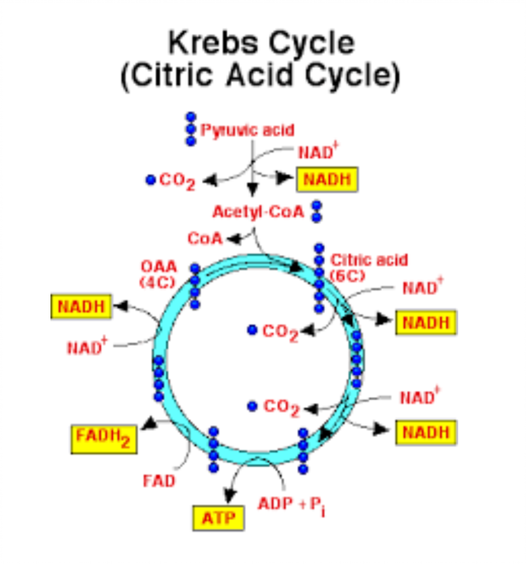

***GLYCOLYSIS***

Glycolysis is the metabolic pathway that converts glucose C6H12O6, into pyruvate, CH3COCOO− + H+. In other words, Glycolysis is the anaerobic process in which one molecule of glucose is oxidized to produce 2 molecules of pyruvic acid.

* Glucose is a stable molecule containing 6 C atoms.
* Glucose contains many C – H bonds.

**The First Stage of Glycolysis**

* Glucose (6C) is broken down into 2 PGAL's (3C)
* This requires two ATP's

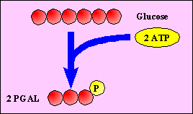

**The Second Stage of Glycolysis**

* 2 PGAL's (3C) are converted to 2 pyruvates
* This creates 4 ATP's and 2 NADH's
* The **net** ATP production of Glycolysis is 2 ATP's

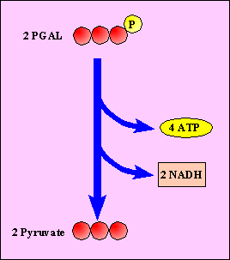

***ELECTRON TRANSPORT PHOSPHORYLATION***

An electron transport chain (ETC) is a series of compounds that transfer electrons from electron donors to electron acceptors via redox (both reduction and oxidation occurring simultaneously) reactions, and couples this electron transfer with the transfer of protons (H+ ions) across a membrane.

The reduced coenzymes produced by the Krebs cycle are immediately used to create ATP. The electrons carried on these molecules are passed down an electron transport chain. Transport of protons creates a large pH gradient across the membrane, and an electric potential caused by the separation of charged ions. The photon gradient is used, as in photosynthesis, to generate ATP.

***BALANCE SHEET FOR AEROBIC RESPIRATION***

|  |  |  |  |  |
| --- | --- | --- | --- | --- |
| ***S. No.*** | ***Process*** | ***NADH*** | ***FADH₂*** | ***ATP*** |
| 1. | Glycolysis | 2 | - | Substrate level phosphorylation = 2  NADH conversion = 4 |
| 2. | Krebs Cycle | 8 | 2 | 2 |
| 3. | Electron Transport Phosphorylation   1. NADH 2. FADH₂ | -  - | -  - | 24 ATP  FADH₂=2 ATP  =4 ATP |
|  | Total | 10 NADH | 2 FADH₂ | 36 ATP |